**Name : Muhammad Shahbaz(21L-7525), Fasih Saqib(21L-5430),Mohib(21F-9054)**

**Section: BCS-5A**

**System Sequence diagram:**

* **Leader:**

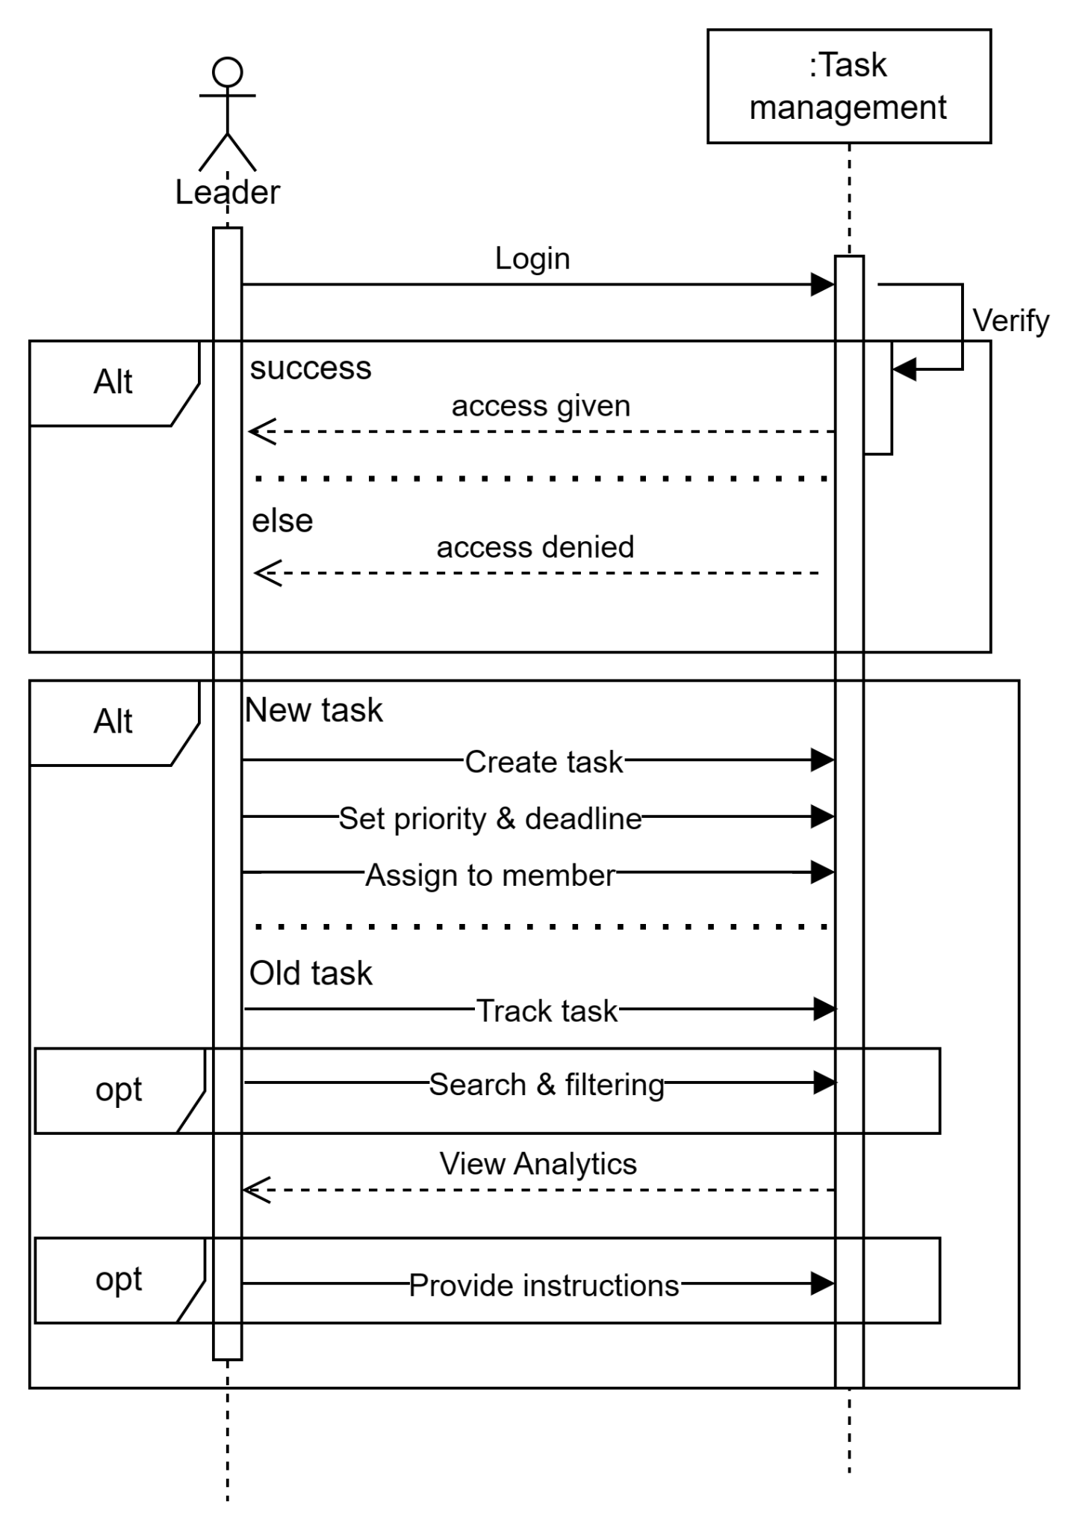

* **Member:**

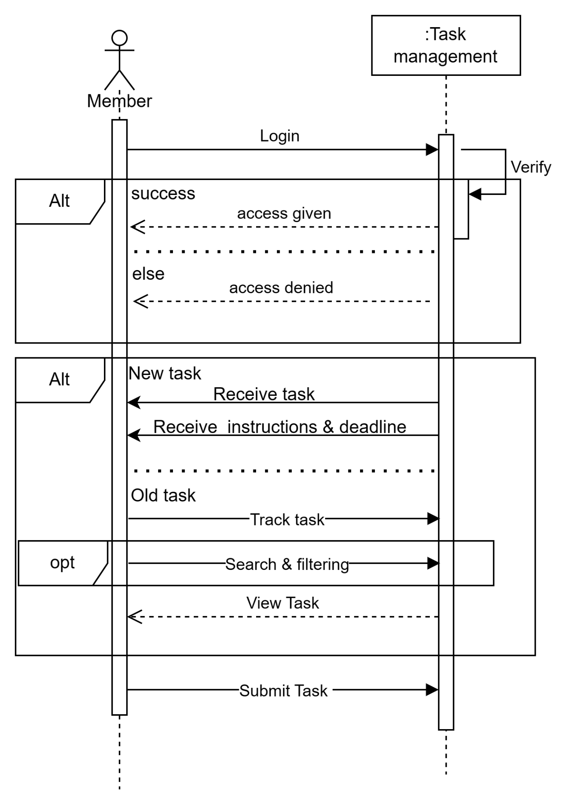

* **Admin:**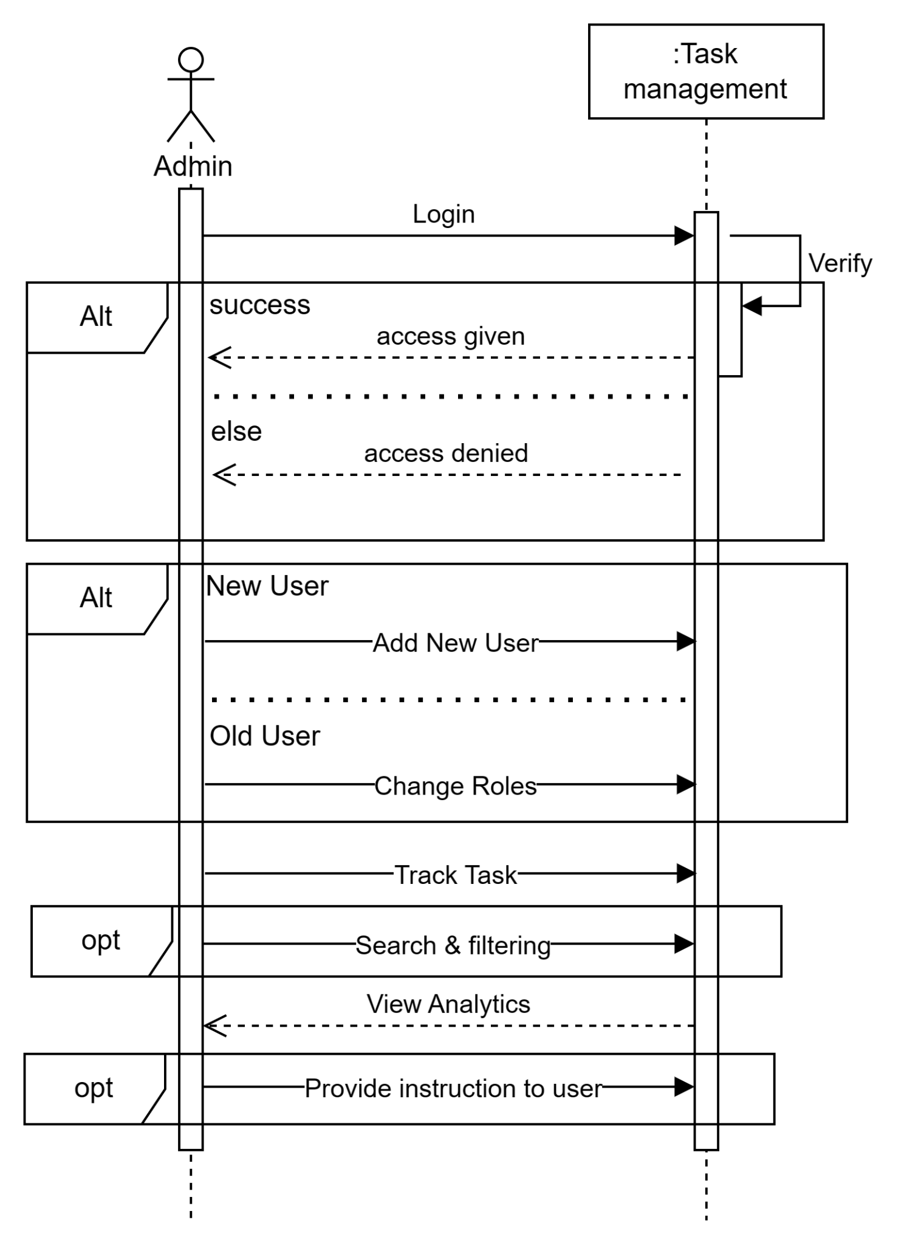

**Operation Contracts:**

* Operation: Create User Account
* Parameters: User information (personal details, credentials)
* Cross References: Use Case 1: Sign Up
* Preconditions:None
* Postconditions: A new user account is successfully created in the system.
* Operation: User Login
* Parameters: Username, password
* Cross References: Use Case 2: Login
* Preconditions: The user account exists.
* Postconditions:The user is successfully logged into the system.
* Operation: View Task Details
* Parameters: Task ID
* Cross References: Use Case 3: Track Task
* Preconditions: The user is logged into the system.
* Postconditions: Task details, including status and assignments, are displayed.
* Operation: Set Priority and Deadline
* Parameters: Task ID, priority levels, deadlines
* Cross References: Use Case 5: Priority and Deadline
* Preconditions: The user is logged in and viewing a specific task.
* Postconditions:The task information is updated with the new priority and deadline.
* Operation: Add Team Leader
* Parameters: Team leader's information, permissions
* Cross References: Use Case 6: Add Team Leader
* Preconditions:The admin is logged in.
* Postconditions: A new team leader is added with the specified permissions.
* Operation: Send Automated Reminders
* Parameters: None
* Cross References: Use Case 8: Receive Reminder
* Preconditions: The user is logged in.
* Postconditions: Automated reminders are sent to relevant users for pending tasks and deadlines.
* Operation: Send Task Reminder
* Parameters: Task details, team members
* Cross References: Use Case 9: Send Reminder
* Preconditions: The user is logged in and viewing task details.
* Postconditions: Reminders are sent to specified team members for overdue tasks.
* Operation: Change User Roles
* Parameters: User ID, new role (Team Leader, Team Member, Admin)
* Cross References: Use Case 11: Change User Roles
* Preconditions: The admin is logged in.
* Postconditions: User roles are updated as per the admin's instructions.
* Operation: Submit Task for Review
* Parameters: Task ID, attached files, comments
* Cross References: Use Case 12: Submit Task
* Preconditions: The user is logged in and assigned a task.
* Postconditions: The task is marked as submitted for review, and relevant parties are notified.
* Operation: Make Changes to Submitted Task
* Parameters: Task ID, revised details
* Cross References: Use Case 13: Instruction for Making Changes to a Submitted Task
* Preconditions: The user is logged in.The task has been submitted for review.
* Postconditions:The task is updated with the changes, and if available, the revised version is marked as "Resubmitted."

**Class Diagram:**

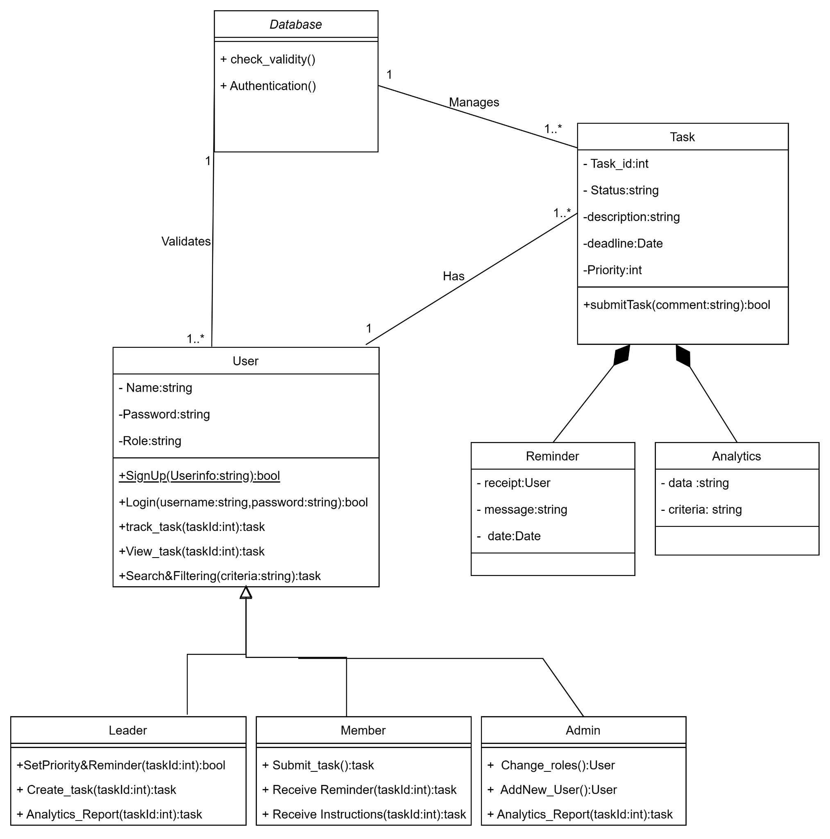

**Data Flow diagram:**

* **Context diagram:**

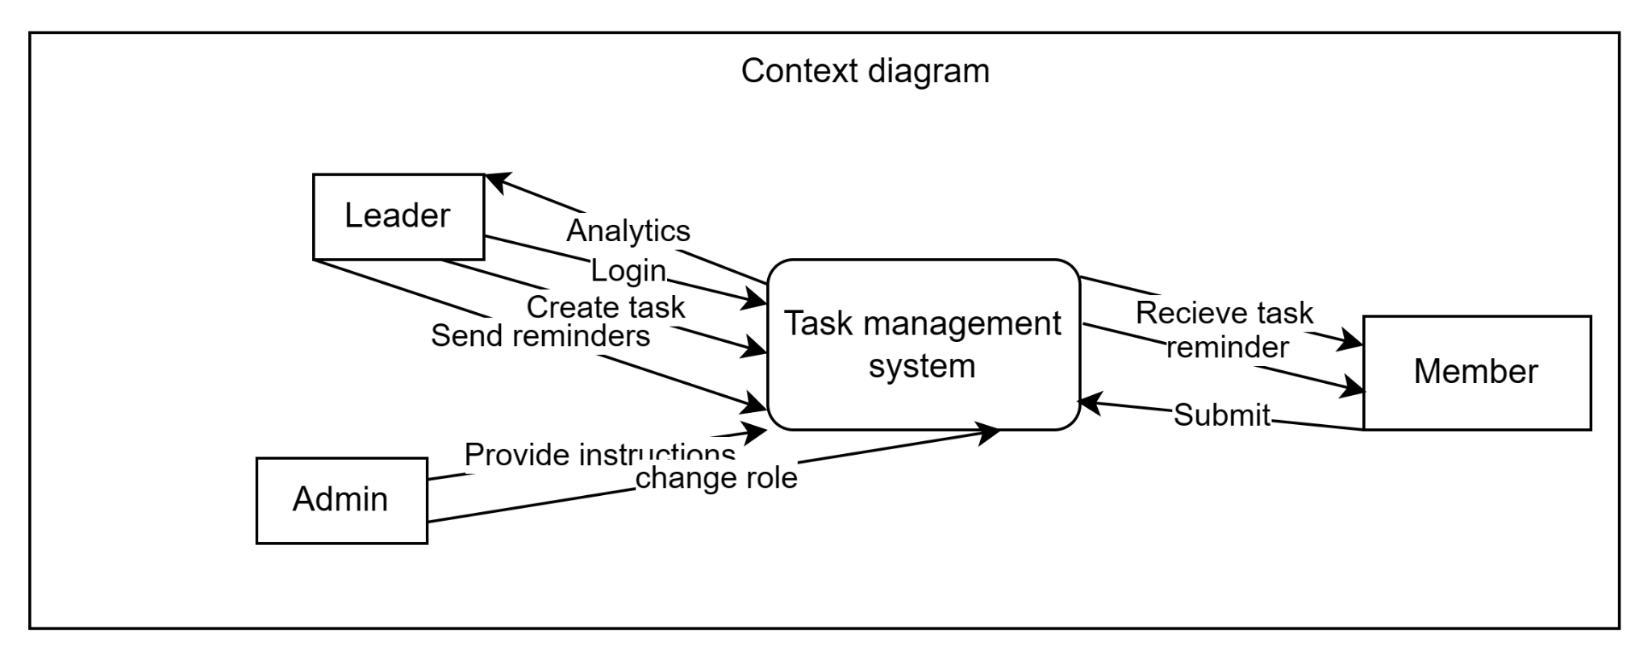

* **Level 1 DFD:**

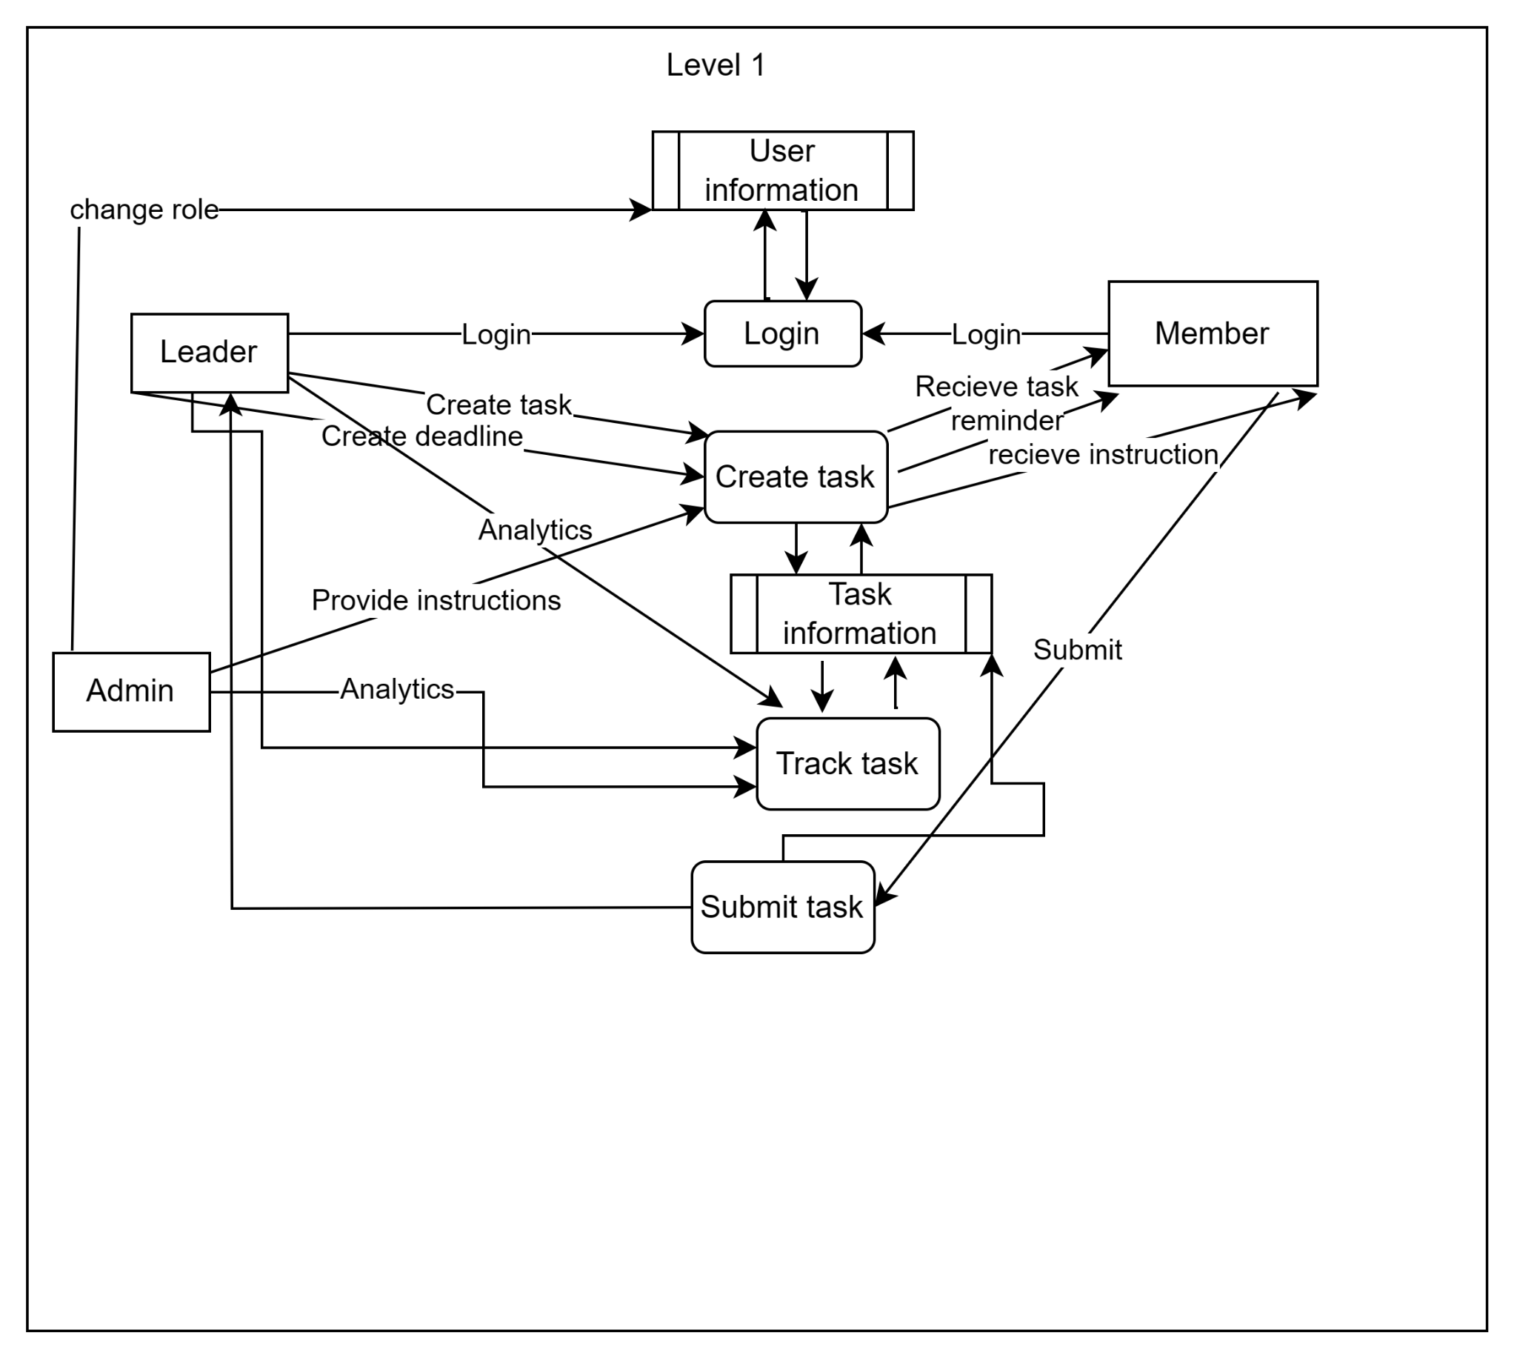

**Sequence diagram:**

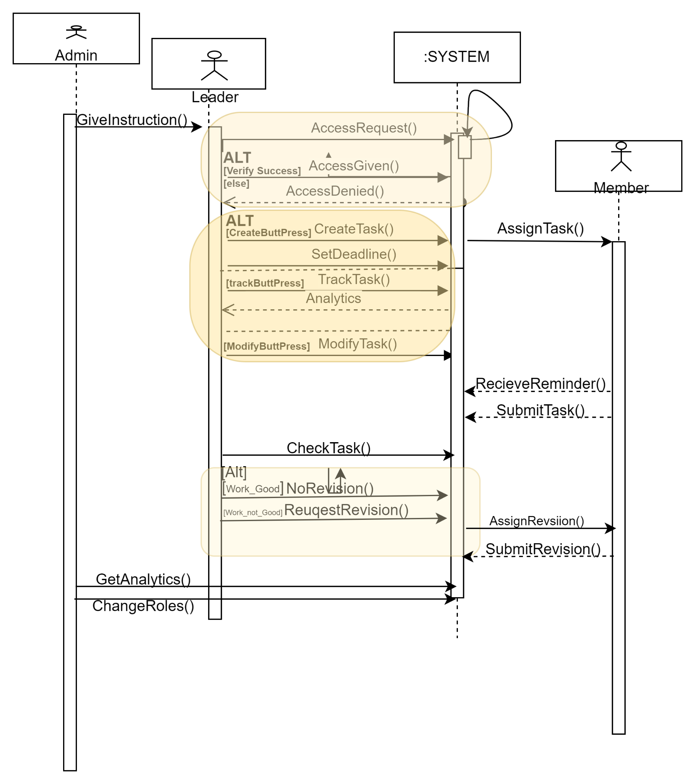

**Collabaration diagram:**

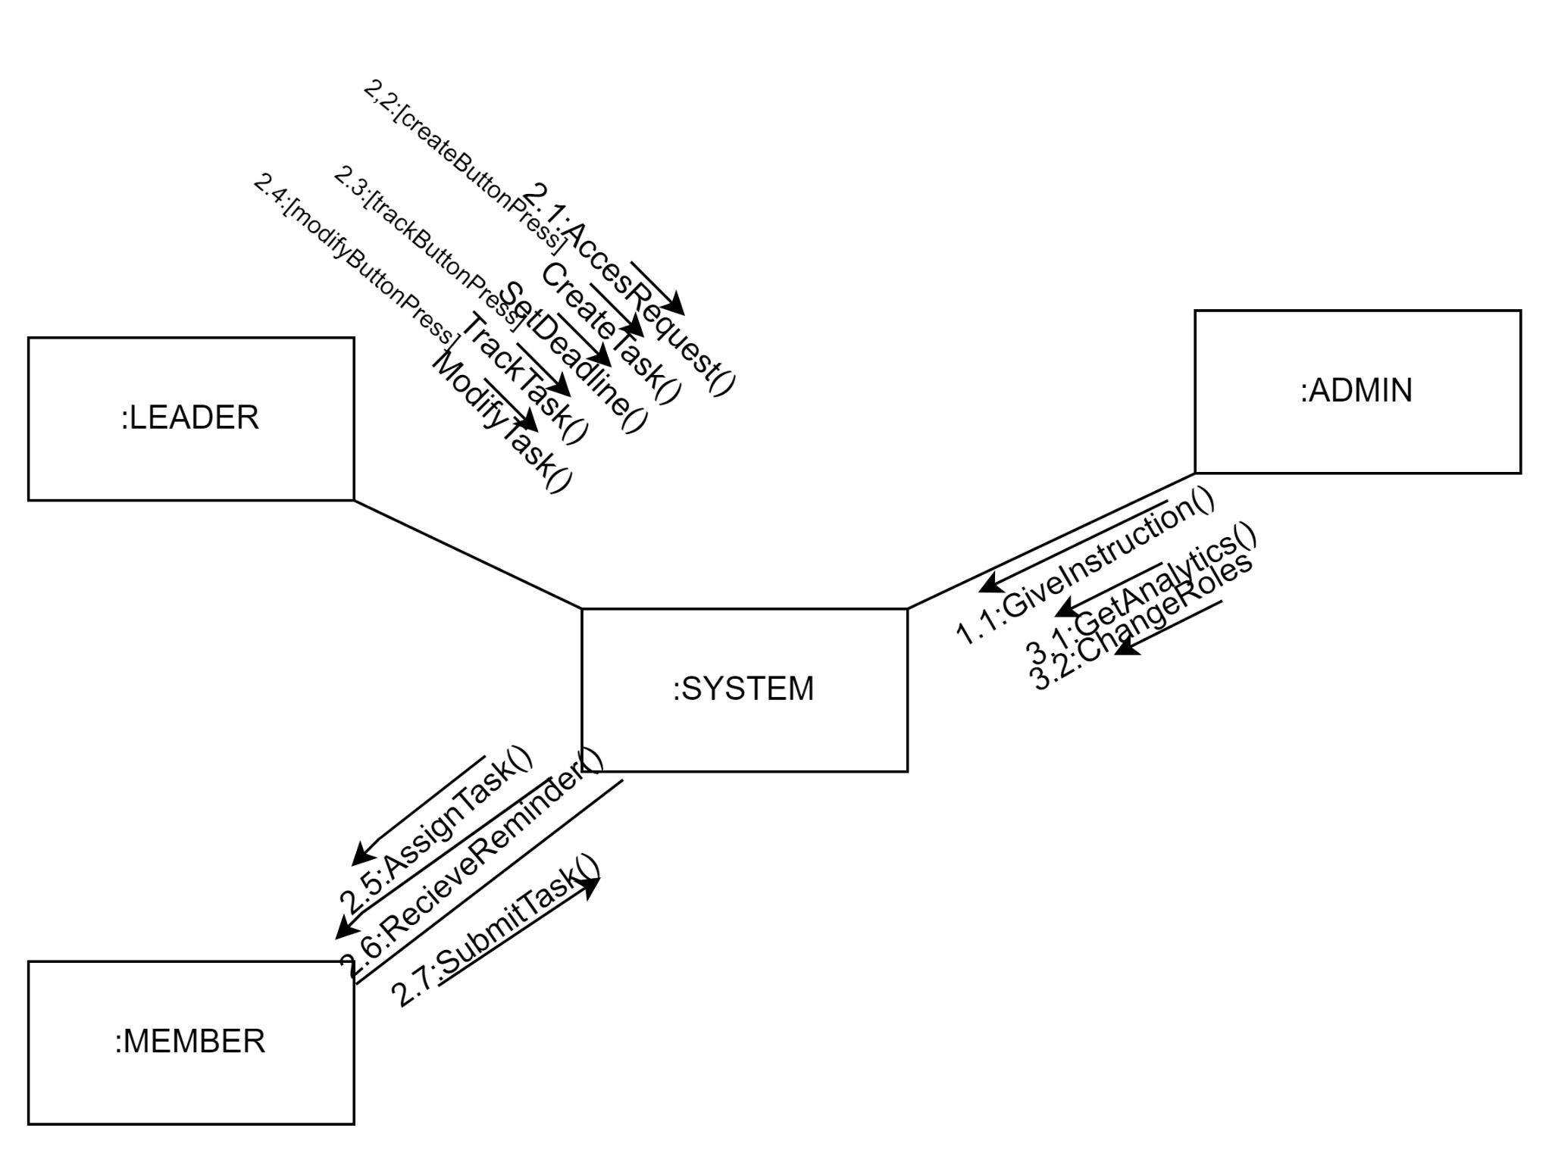

**Component diagram:**

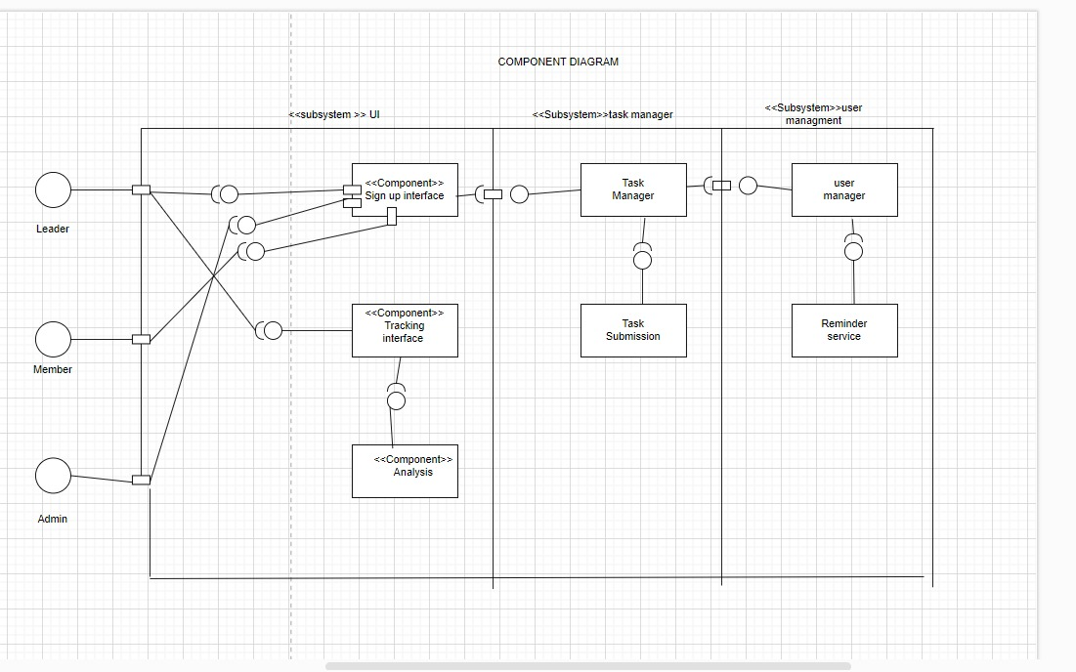

**Package diagram:**

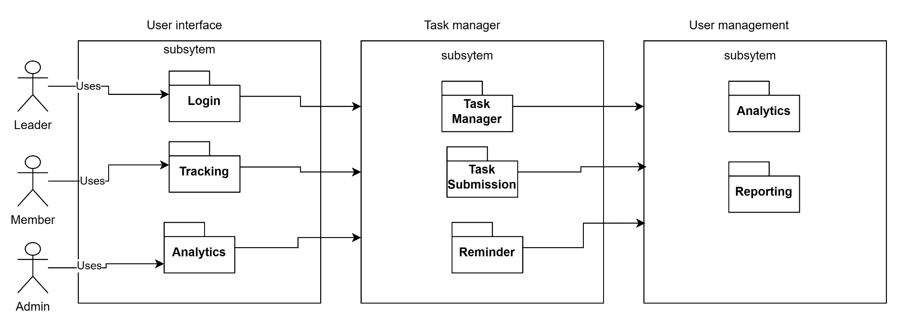

**Deployment diagram:**

